**PROBLEM:**

**2.1:Curve fitting of straight line**

**2.2:Curve fitting of Parabola**

**Objective:**

How to make an accurate curve of a straight line and a parabola from some given points and their graphical representation using MATLAB.

**Code(2.1):**

close all;

clear all;

clc;

n=input('How many inputs: ');

for i=1:1:n

x(i)=input('Input (x): ');

end

for i=1:1:n

y(i)=input('Input (y): ');

end

plot(x,y)

hold on;

sx=0;

sy=0;

xy=0;

xx=0;

for i=1:1:n

sx= sx+x(i);

sy= sy+y(i);

xy= xy+x(i)*y(i);

xx= xx+x(i)*x(i);

end;

a1 = (n*xy-sx*sy)/(n*xx-sx*sx);

a0 = (sy-a1*sx)/n;

for i=1:1:n

p(i)=a0+a1*x(i);

end;

plot(x,p);

xlabel('X');

ylabel('Y');

title('Curve Fitting: Straight Line');

**Output:**

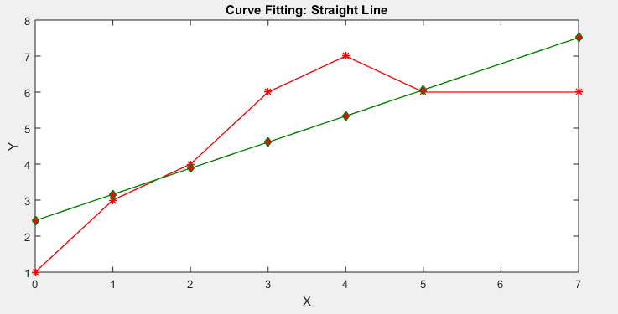

**Code(2.2):**

clc;

close all;

clear all;

n = input('Data limit : ');

for i=1:1:n

S1(i)=input('Data (x): ');

end

for i=1:1:n

S2(i)=input('Data (y): ');

end;

x = 0;

y = 0;

xy = 0;

x2 = 0;

x2y = 0;

x3 = 0;

x4 = 0;

for i=1:1:n

x = x + S1(i);

y = y + S2(i);

xy = xy + S1(i)*S2(i);

x2 = x2 + S1(i)*S1(i);

x2y = x2y + S1(i)*S1(i)*S2(i);

x3 = x3 + S1(i)*S1(i)*S1(i);

x4 = x4 + S1(i)*S1(i)*S1(i)*S1(i);

end

c=n*(x2*x4-x3*x3)+x*(x3*x2-x*x4)+x2*(x*x3-x2*x2);

a0=y*(x2*x4-x3*x3)+x*(x2y*x3-xy*x4)+x2*(xy*x3-x2*x2y);

a0=a0/c;

a1=n*(xy*x4-x3*x2y)+y*(x3*x2-x*x4)+x2*(x*x2y-xy*x2);

a1=a1/c;

a2=n*(x2y*x2-xy*x3)+x*(xy*x2-x*x2y)+y*(x*x3-x2*x2);

a2=a2/c;

for i=1:1:n

S3(i)=a0+a1*S1(i)+a2*S1(i)*S1(i);

end

plot(S1,S2);

hold on;

plot(S1,S3,'green');

xlabel('X');

ylabel('Y');

title('Curve Fitting: Parabola');

**Output:**

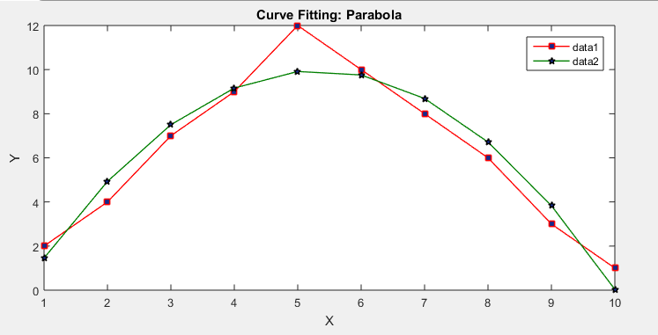

**Discussion:**

In this lab, a code is written in MATLAB to take some random input for (x, y) both for straight line and for parabola. But they don’t actually make an accurate curve. The main procedure of the code is generating the co efficent of x & y so that the curve becomes perfect straight line and parabola.The lab is done successfully.The original curve And Fitted curve are showed both on the figure(s) for Straight line & parabola.